Password Reset via Active Directory

Objective
Reset an employee's password via Active Directory. Exclusive process for the Help Desk Analyst.

Responsibility
Exclusive to the Help Desk Analyst with access to the AD server (PS account).

Step-by-Step
- Access Remote Desktop (C:\Windows\System32\mstsc.exe):
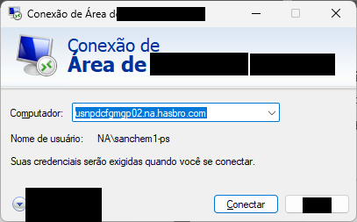
- Access the server "usnpdcfgmgp02.na.contoso.com".
- Use your PS account (username-PS) in Secret Server — Service Portal:
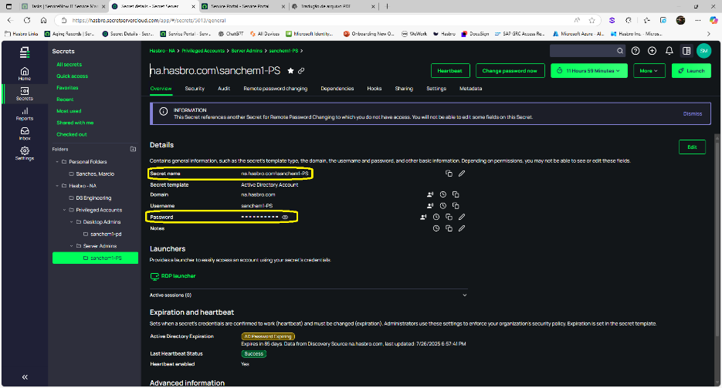
- Go to "Tool → Active Directory Groups And User".
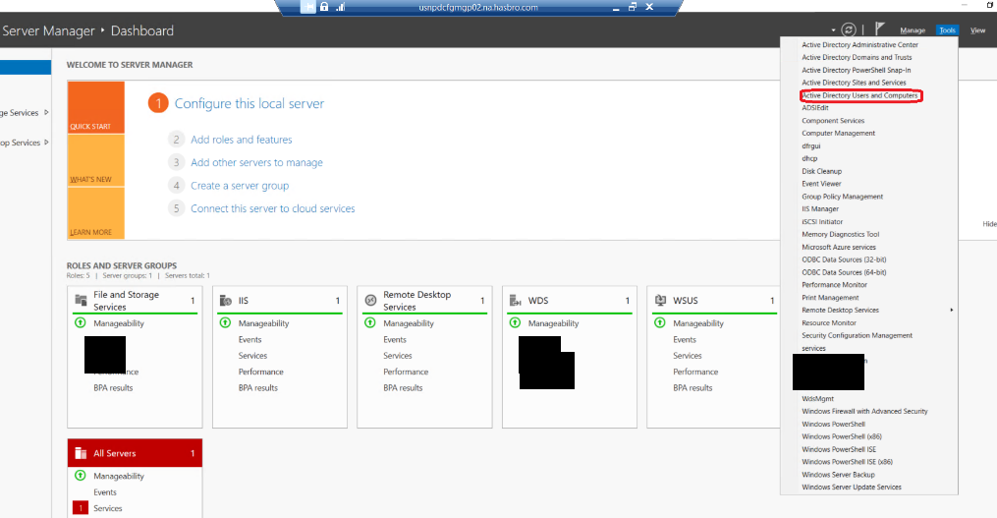
- Use the search field to locate the "user name" or full name of the employee.
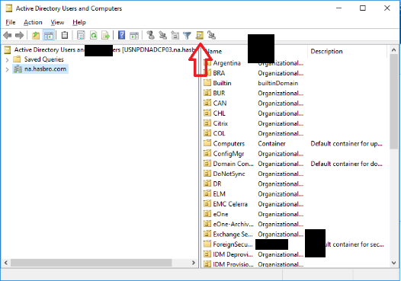
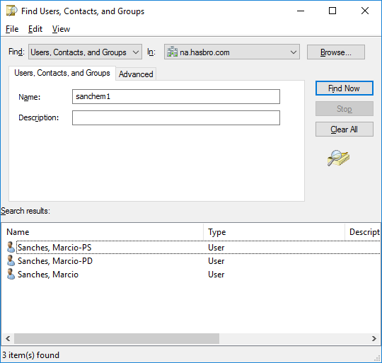
- Right-click the located user and select "Reset Password".
- Uncheck "User must change password at next logon" and set a new password following the standard: uppercase and lowercase letters, numbers, and special characters.
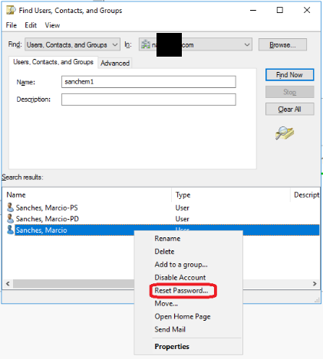
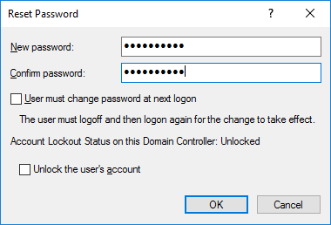

Version History
IT Team | 1.0 | 28/07/2025 | Creation
Lucas Souza | 2.0 | 04/03/2026 | Change
Lucas Souza | — | Jun/2026 | Process separation
Lucas Souza | — | Jun/2026 | Document standardization

